***Dt : 25/4/2022(Syllabus)***

***Writing,Saving,Compiling and Execution Java Program:***

***define Program?***

***=>Program is a set of Instructions.***

***define Programming?***

***=>The process of constructing programs is known as Programming.***

***Note:***

***=>The process of generating Source Code from 'project Analysis and***

***project design' is known as Programming or Coding.***

***define Programmer?***

***=>The person who writes the programs is known as Programmer.***

***------------------------------------------------------------***

***\*imp***

***Stages of Program:***

***=>After writing the program,we save the program with language***

***extention***

***Ex:***

***Test.c***

***Test.cpp***

***Test.java***

***=>After saving the program,the program will have the following***

***two stages:***

***1.Compilation***

***2.Execution***

***1.Compilation:***

***=>The process of checking the program constructed according to***

***the rules of language or not,is known as Compilation process.***

***=>After Compilation process is Successfull,***

***=>C and c++ programs generate Objective Code***

***=>Java programs generate Byte Code***

***Note:***

***=>C,C++ and Java languages will use Compiler in Compilation stage.***

***2.Execution:***

***=>The process of running the compiled codes and checking the***

***required output is generated or not,is known as Execution process.***

***Note:***

***=>In c and c++ languages the Objective Code is converted into***

***Executable code and generate result.***

***=>In Java Language the Byte Code is executed on JVM(Java Virtual***

***Machine).***

***Diagram:***

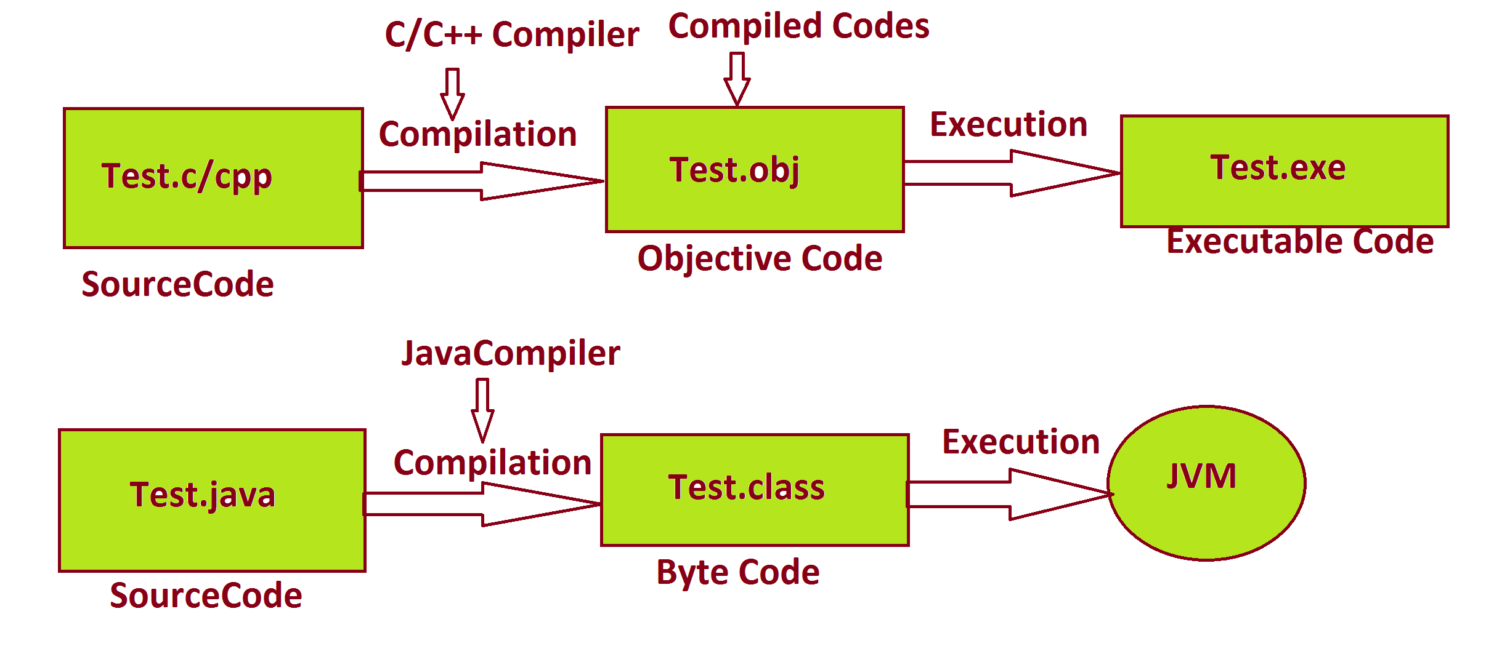

***=========================================================***

***faq:***

***wt is the diff b/w***

***(i)Objective Code***

***(ii)Byte Code***

***(i)Objective Code:***

***=>The Compiled Code generated from c and c++ programs is known as***

***Objective Code.***

***=>while Objective Code generation Operating System is participated,***

***because of this reason Objective Code is PlatForm dependent code.***

***DisAdvantage:***

***=>The Objective Code which is generated from one PlatForm cannot be***

***executed on other PlatForms.***

***Note:***

***=>c and c++ languages which are generating Objective Code are***

***PlatForm dependent languages.***

***(ii)Byte Code:***

***=>The compiled code generated from JavaPrograms is known as Byte***

***Code.***

***=>while ByteCode generation Operating System is not participated***

***because of this reason,Byte Code is PlatForm independent code.***

***Advantage:***

***=>The ByteCode generated from One platform can be executed on***

***all platform where JVM is available.***

***Note:***

***=>JavaLanguage which is generating ByteCode is PlatForm independent***

***Language.***

***Diagram:***

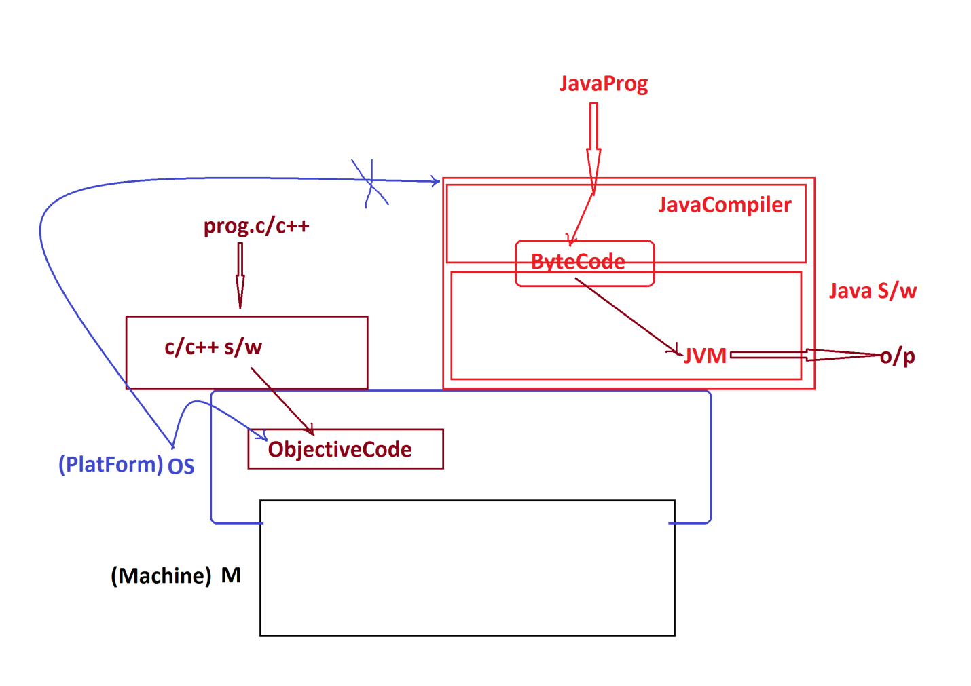

***===============================================================***

***Dt : 26/4/2022***

***faq:***

***define High Level language?***

***=> The Language programs which are constructed from User understandable***

***formats,is known as High Level Language.***

***faq:***

***define Low Level Language ?***

***=>The Language programs which are constructed from the formats which***

***are not understandable by the users,is known as Low Level Language.***

***faq:***

***define Translators?***

***=>Translators are used to translate High Level Language formats into***

***Low Level Language formats and Low Level language formats into High***

***Level Language formats.***

***=>These Translators are categorized into two types:***

***(i)Compiler***

***=>Compiler translates the total program at-a-time.***

***(ii)Interpreter***

***=>Interpreter translates the program line-by-line.***

***Diagram:***

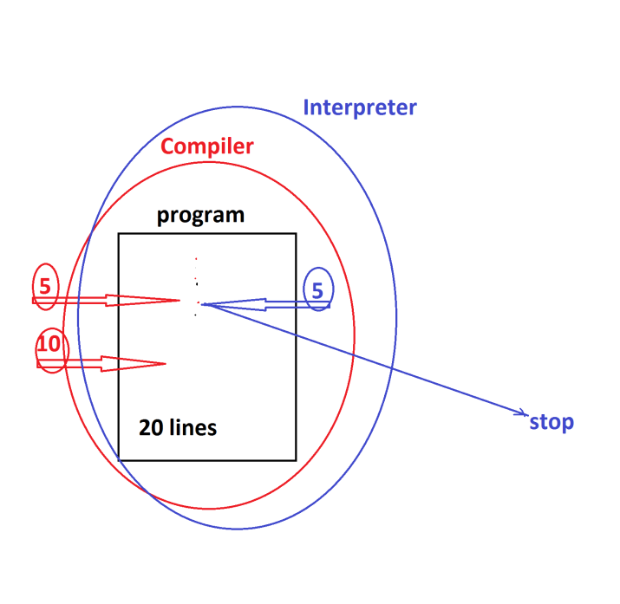

***Note:***

***=>C,C++ and Java Languages will use compiler in Compilation process.***

***=>C and C++ languages will use Compiler in execution process,but***

***Java language will use "Interpreter and Compiler" in execution process.***

***=====================================================================***

***"James Gosling"***

***Sun Micro Systems - 1991***

***=>Code Writer(Programmer)***

***WORA - Write Once and Run Anywhere***

***Test.gt(green talk)***

***OAK Language***

***Java - 1995***

***Java Versions:***

***1995 - Java Alpha&Beta***

***1996 - JDK 1.0***

***1997 - JDK 1.1***

***1998 - JDK 1.2***

***2000 - JDK 1.3***

***2002 - JDK 1.4***

***----------------------------------***

***2004 - Java5***

***=>JDK 1.5***

***=>JRE 1.5***

***2006 - Java6***

***=>JDK 1.6***

***=>JRE 1.6***

***2011 - Java7***

***=>JDK 1.7***

***=>JRE 1.7***

***-------------------------------------***

***2014 - Java8***

***=>JDK 1.8***

***=>JRE 1.8***

***2017 - Java9***

***=>JDK 1.9***

***=>JRE 1.9***

***2018 - Java10 and Java11***

***2019 - Java12 and Java13***

***2020 - Java14 and Java15***

***2021 - Java16 and Java17***

***2022 - Java18***

***==============================================================***